VILNIUS UNIVERSITY
FACULTY OF CHEMISTRY AND GEOSCIENCES
INSTITUTE OF CHEMISTRY
NAME OF THE DEPARTMENT

Name Surname
Degree programme
Report of Scientific Research Work X/X p.

TITLE OF THE REPORT

Scientific adviser
prof. dr. Name Surname

Vilnius 20XX

TITLE OF CHAPTER

Text text text text text text text text text text text text text text text text text text text text text text text text text text text text text text text text text text text text text text text text text text text text text text text text text text text text text text text text text text text text text.
Text text text text text text text text text text text text text text text text text text text text text text text text text text text text text text text text text text text text text text text text text text text text text text text text text text text text text text text text text text text text text text text text text text text text text text text text text text text text text text text text text text text text text text text text text text text text text text text text text text text text text text text text text text text text text text text text text text text text text text text text text text text text text text text text text text text text text text text text text text text text.

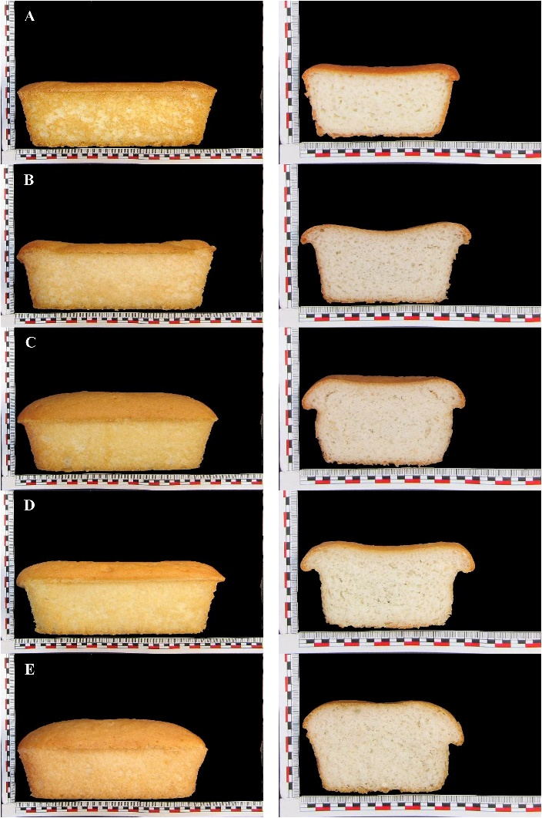
Fig. 1. Effect of Addition of MW-treated Rice Flour on Viscoelastic Behaviour and Bread-making Performance of Gluten-free Dough.
A: Control 100 % rice flour, B: 30 % addition of treated rice flour at 20 % of Initial Moisture Content, C: 30 % addition of treated rice flour at 30 % IMC, D: 50 % addition of treated rice flour at 20 % IMC, E: 50 % addition of treated rice flour 30 % IMC [1].

Text text text text text text text text text text text text text text text text text text text text text text text text text text text text text text text text text text text text text text text text text text text text text text text text text text text text text text text text text text text text text.
Text text text text text text text text text text text text text text text text text text text text text text text text text text text text text text text text text text text text text text text text text text text text text text text text text text text text text text text text text text text text text text text text text text text text text text text text text text text text text text text text text text text text text text text text text text text text text text text text text text text text text text text text text text text text text text text text text text text text text text text text text text text text text text text text text text text text text text text text
text text text text text text text text text text text text text text text text text text text text text text text text text text text text text text text text text text text text text text text text text text text text text text text text text text.

Table 1. List of cases.
No. | Case | Date | Result
 | Case 1 | 25/01/2019 | Negative
 | Case 2 | 16/02/2019 | Positive

Text text text text text text text text text text text text text text text text text text text text text text text text text text text text text text text text text text text text text text text text text text text text text text text text text text text text text text text text text text text text text text text text text text text text text text text text text text text text text text text text text text text text text text text text text text text text text text text text text text text text text text text text text text text text text text text text text text text text text text text text text text text text text text text text text text text text text text text text
text text text text text text text text text text text text text text text text text text text text text text text text text text text text text text text text text text text text text text text text text text text text text text text text text text text text text text text text text text text text text text text text text text text text text text text text text text text text text text text text text text text text text text text text text text text text text text text text text text text text text text text text text text text text text text text text text text text text text text text.

REFERENCES

1. M. Villanueva, J. Harasym, J. M. Muñoz ir F. Ronda, Rice flour physically modified by microwave radiation improves viscoelastic behavior of doughs and its bread-making performance, Food Hydrocolloids, 90 (2019) 472–48.

